Oxfordshire Infrastructure Strategy (OxIS)

Report Purpose

- At the Growth Board in May 2016, the Board approved the commissioning of an Oxfordshire Infrastructure Strategy (OxIS).

- Since that date the Project Steering Group have overseen the completion of the project, assisted by the consultants - AECOM.

- The final report on the project has now been completed and the report ready to be published on the Growth Board web pages of the County Council website.

- This report and the presentation accompanying it at the meeting, introduces this final report to the Board and asks for the approval of the report and its conclusions.

Recommendation

- That the Growth Board approves the OxIS report and the conclusions contained therein

- That the Board approves the ranking of the regional and countywide projects in the OxIS report.

(iii) That the Board agrees to the periodic update of OxIS and asks officers to build this into the Board’s Work Programme and budgets

Background

- At the Growth Board in May 2016, the Board agreed the commission of OxIS and asked officers to appoint consultants to progress the project, overseen by a Project Steering Group drawn from across local authority partners, together with input from other Growth Board partners, for example the Environment Agency.

- The report set out the advantages of developing OxIS, namely a collation and summation of Oxfordshire’s strategic infrastructure requirements to meet agreed growth and a countywide base line upon which to base potential further growth and related infrastructure funding decisions.

- The report also stated that the intention was that OxIS would support and build upon Local Plans and be able to integrate with any proposed development of sub-national/ regional planning.

- Finally, the report stated that an integral part of the OxIS project should be public and stakeholder engagement to ensure wide ownership and understanding, not just of the headline outcomes of OxIS but also of its longer-term purpose as a basis for future discussions with Government, infrastructure funders, and providers.

Project Outline

- The project is split into four separate sections, these are:

- Completion of a base line report, called a Stage One Report that sets out all the infrastructure proposals, intentions and challenges drawn from across all Growth Board partners and other key stakeholders.

- The completion of the second stage of the project, originally an exercise in grouping the locally focused infrastructure into relevant growth corridors or petals and ranking the infrastructure requirements identified in stage one.

- A detailed engagement process with stakeholders, complemented by public consultation to test the information in the Stage One report, its assumptions and conclusions and the ranking criteria in the final report.

- The completion of a final OxIS report for consideration by the Board in September 2017.

Completion of Stage One

- The first stage of the project was concerned with drawing together all the existing infrastructure needs already established for Oxfordshire as set out in District and City Local Plans, the County Council’s Local Transport Plan and in the investment strategies of infrastructure providers.

- Partners completed this in consultation with infrastructure providers via a series of seminars where we collectively considered and evaluated scenarios.

- The conclusion of the stage one work was a tabulated summary of the entire infrastructure required to support planned growth in Oxfordshire.

- The costs of the infrastructure were also estimated and used to calculate a “gross funding gap” that would need to be filled; either by government grant, developer contributions or via investment from infrastructure providers. OxIS estimated the total infrastructure requirement at that time to be £8.96 billion, with a funding gap of £8.45 billion (price point based on 2016 terms)

- The conclusions of the stage one work were completed and published in April 2017. The full report is available on the Growth Board web pages: https://www.oxfordshire.gov.uk/growthboard.

Completion of Stage Two

- Upon the completion of Stage One, the second stage of the project was to take the infrastructure requirements identified and rank them in order according to a scheme of agreed assessment criteria.

- The original intention of the project was that this stage would include a prioritisation exercise for all identified infrastructure schemes. However, as the OxIS project has progressed the Steering Group’s thinking on the outcomes of the project have matured and the following approach implemented.

- Firstly, OxIS moved from one of prioritisation to one where infrastructure is ranked. The Steering Group felt this was an important distinction in the sense that OxIS sets out the totality of infrastructure Oxfordshire needs to support growth and it is not a matter of choices as to what does or does not happen. Instead, it is about what the appropriate order would be to deliver growth sustainably, given the constrained funding available.

- Secondly, the project split the infrastructure requirements identified in OxIS between those that had a regional and/or countywide focus and those that were specific to a locality. Those more locally focussed infrastructure requirements were then grouped into growth corridors or petals.

Ranking of Infrastructure Schemes

- At the last Board meeting, a presentation from the consultants introduced Board members to the ranking criteria the Growth Board Executive Officer Group (EOG) were recommending. The agreed criteria are as follows:

- Ability to unlock, enable or facilitate development
- Quantum of homes and jobs that would be facilitated as a result
- Deliverability
- Degree of interdependency with other projects
- Social impacts, e.g. extent to which project impacts upon health and well-being of population, learning, and skill development opportunities.
- Environmental impacts, e.g. extent to which project impacts upon natural and or urban environment and local air quality and noise

- The criteria were recommended by EOG as those that best reflected the purposes of OxIS. The rationale for the criteria was as follows.

- For the first criteria, all schemes were scored against whether they either unblocked growth, enabled planned growth, mitigated existing or planned growth or safeguarded property. Each scheme could only be scored against one of these four categories.; The group agreed this as the primary criteria reflecting the central purpose of OxIS that was to understand what infrastructure was needed to deliver our growth ambitions in the most sustainable way.

- The second criteria, quantum of homes/jobs delivered reflected the quantitative impact the infrastructure would have on growth.

- The third and fourth set of criteria focused upon complexity, interdependency, and deliverability of schemes as the main components of any issues that would influence the ability of the infrastructure scheme to be completed.

- The final two criteria focused upon the wider social and environmental impacts of the schemes and was an attempt to factor in the wider impacts, positive and negative of the proposed schemes.

- A table demonstrating the ranking criteria is attached at Appendix One of the report.

Application of the ranking schemes

- Having agreed a ranking scheme for OxIS, the Steering Group considered how best to apply the ranking to the projects and whether, having separated the projects between those with a national/regional focus and those with a more local impact the ranking would be applicable for both groups.

- The conclusion of the Steering Group was that the ranking criteria were equally relevant to all the schemes identified in OxIS, but that for the purposes of presentation and of highlighting the key messages we wanted OxIS to promote, that a different approach would be taken dependent upon the schemes.

- For the national and regional schemes the ranking would be promoted. The rationale for this was that such a ranking exercise gives a clear message to Government about what is most important for Oxfordshire.

- For the local schemes, the Steering Group adopted a different, more flexible approach where those schemes, all of which have been identified as essential, are ranked in the report but for the purposes of presentation are listed. This is because Steering Group concluded that whilst ranking of local schemes will be useful in future funding negotiations and bids, listing better reflects the outcomes of OxIS, namely that it is difficult to differentiate between the various local infrastructure projects in a manner that would be helpful.

- The conclusions of the ranking exercise are highlighted below in the section entitled OxIS findings.

Communications and Engagement

- The Board will recall that a key commitment of the OxIS project was to engage with stakeholders, interested parties and the public in the process of finalising the report for the Board.

- At the last meeting the Board approved a Communications and Engagement Plan that set out three methods of engagement, these were:

- For infrastructure providers who have already fed into the preparation of the stage 1 report via attendance at workshops; a mail out with all relevant information inviting comments and informing them of the dates when material will be available online for the public to feedback.
- For interested parties/wider stakeholders, an invite to a drop in session.
- For the public, a press release and an upload of information onto the Growth Board web pages, with an opportunity to comment via a response tab.

- The Board hosted a drop in engagement session on 6th September at SAID Business School, attended by around 40 organisations/ individuals.

- The intention of the session was to offer an opportunity to share the methodology behind the project and understand any issues and concerns before the strategy is finalised. Local press and television also attended the session.

- In addition, the Board had received, at the time of writing of this report 69 responses.

- AECOM have, as part of their commission collated all comments received and these are summarised in the main body of the OxIS report, however in summary the key messages are:

- The majority of respondents stated that they support the development of a countywide infrastructure strategy
- Some respondents, although welcoming a joined up strategy, question the timing of its production, and would like to have seen the infrastructure strategy developed up front, ahead of Local Plan major growth allocations.
- Questioning if the growth forecasts are realistic - respondents recognise that housing construction has not kept pace with our ambitions or new jobs growth
- Investment in active modes and public transport should be prioritised to ensure sustainable and healthy communities, questioning the value of major investment in new highway schemes, such as Oxford to Cambridge Expressway.
- We should place more emphasis on Green Infrastructure, the historic environment and understanding the economic environmental value of Oxfordshire.
- Questioning the strategy for future electricity grid supply and lack of strategic overview as to how this should develop to meet growth demands (sustainably)

- Finally, the Board may also have noted that OxIS received extensive and positive local television coverage, thus ensuring that the messages about OxIS, its aims and purpose were widely understood.

OxIS Findings.

- As previously discussed, the conclusions of OxIS have separated the various infrastructure schemes between those that have a national or regional importance and those which have a more local or Oxfordshire focus. These are discussed in turn.

National/Regional Schemes

- The table at Appendix Two of the report demonstrates the application of the ranking to the regional and countywide schemes. The presentation and subsequent discussion will address the detail of the conclusions of OXIS, however for the purpose of this report there are some key messages that officers would wish to highlight to the Board.

- The Board will note the ranking of the Regional and Countywide schemes and the preponderance of rail and transport schemes, reflecting the fact that movement and connectivity are central to delivering sustainable growth.

- The highest ranked schemes are so because, in accordance with the agreed criteria, they enable or unlock proposed development, recognising the fact, that significant investment in Oxfordshire is needed if we are to deliver our growth commitments.

- The priority given to the importance of growth and connectivity means that some other schemes, such as for example green infrastructure are not perhaps given the profile that some stakeholders might expect. Officers on the Steering Group have recognised this within the OxIS findings and have noted the need to consider issues such as green infrastructure, utility capacity and their importance to sustainable growth in another way, perhaps for example through the proposed Joint Spatial Plan or separate specialist strategies.

Countywide/Local Schemes

- In paragraphs 18 and 25 the report highlighted the fact that the Steering Group had opted to group infrastructure schemes with a local focus into growth petals or corridors. The petals will be highlighted in the presentation to the Board and displayed at the meeting.

- The rational for grouping the schemes into growth corridors was that it helps us to demonstrate the collective growth patterns within Oxfordshire that have to date been articulated through a range of Local Plans and the Local Transport Plan. In this regard, the petals are a diagrammatic illustration of how growth is dispersed across the county and the infrastructure that relates to it.

- Having collated the various projects into petals, the Steering Group examined the rankings for the different schemes. The ranking exercise within each growth petal
is contained within the main OxIS report and will be discussed in detail in the presentation to the Board.

- The key messages from the ranking of the local schemes is however a different one from the ranking of the national/regional schemes. What the exercise demonstrated was that, although a ranking exercise was undoubtedly useful and would assist us in discussions with infrastructure providers and funders; it was very difficult to be able to rank the schemes in such a way as to provide a clear hierarchy in the manner that we had been able to do for the national schemes. Instead, it highlighted that, within each growth petal the entire infrastructure was both essential and inextricably interlinked - all items were required to ensure that the growth within each petal would be sustainable.

- Accordingly, the headline presentation for countywide/local schemes is one of a listing rather than a ranking, thus demonstrating the importance of the totality of this more locally focussed infrastructure to Oxfordshire’s sustainable growth.

OxIS Funding Gap

- The Board will recall that in the presentation to the July meeting, that we highlighted the findings of the stage one report that there was a funding gap of £8.45bn.

- As part of the Stage Two work, this “gross” figure has been refined as more and better-detailed information has become available. Accordingly schemes and costings have been revised, resulting in a revised total infrastructure cost of £8.35bn and a gross funding gap of £7.14bn

- The Board will also be should be aware from that presentation that this is a “gross” figure that does not, particularly for the schemes in the local growth petals reflect the contributions that developers and infrastructure providers will make to the costs through the planning process, through either S106 agreements or CIL contributions. Instead it is a headline that demonstrates the scale of costs of our growth ambitions and the funding challenge that we collectively face

Project Budget

- When the Board approved the OxIS project, it also approved a budget of £120,000, with an agreed split of £20,000 from each authority.

- The cost of the successful tender from AECOM was £109,605. However, additional work has been required of the consultants by the Steering Group and a revised bill of £127,464 agreed. Accordingly, the lead authority has billed each local authority partner with the agreed contribution towards the costs of OxIS.

OxIS Refresh

- One key finding of the Steering Group is that although OxIS is a valuable piece of work, as a strategy based upon information available at a point in time its continued value will be dependent upon it being refreshed periodically.

- The Steering group accordingly ask the Board to recognise the need for OxIS to be refreshed periodically and to receive at a future meeting a short paper setting out the timescale and likely costs for this exercise for budgeting and programme management purposes.

Conclusions

- When the Board initiated the OxIS project, it was anticipated that the completion date would be April 2017.

- The project has however experienced some managed delays, mostly caused by partners completing OxIS alongside the peaks and troughs of workloads as several of them have worked through various stages of their Local Plans.

- Notwithstanding this, the OxIS project is complete and in the Steering Group’s opinion is a high quality piece of work, which goes beyond what other authorities have produced.

- OxIS will accordingly prove invaluable to Oxfordshire as we plan for the future, firstly by informing future spatial planning at both county and district level, secondly, by supporting the development of sub regional transport and infrastructure planning, and finally in negotiations with Government and other investment agencies for funding for the infrastructure identified as required.

Appendix One- Ranking criteria

Theme | Criteria | Description | Score
Project Type | Unblocking Stalled Development | Projects that unlock stalled development sites to enable growth
 | Enabling New Development | Projects that address existing infrastructure capacity issues and enable new development sites.
 | Mitigating Development | Projects that address the additional infrastructure burden generated by a proposed development site (either by expanding or improving existing infrastructure or by providing new infrastructure).
 | Safeguarding Development | Projects that safeguard existing homes or jobs
Growth Supported | Homes Supported | What scale of housing delivery is enabled by the implementation of this infrastructure project?
 | Jobs Supported | What scale of economic development (employment sites) is supported by the implementation of the infrastructure project
Deliverability | Level of Commitment | Projects that are committed to, in terms of funding and schemes that are at an advanced stage
 | Complexity of Delivery | The project has issues (outside funding) that require resolving prior to delivery. E.g. number of delivery partners involved, complexity of land assembly, length of construction period.
 | Interrelationships | The extent to which the infrastructure project has interrelationships with other projects
Associated Impacts | Social Benefits | Extent to which project impacts upon health of population, employment opportunities, learning and skill development opportunities
 | Environmental Benefits | Extent to which project impacts upon natural and or urban environment, local air quality and noise

Appendix Two: ranking of Regional/Countywide Schemes

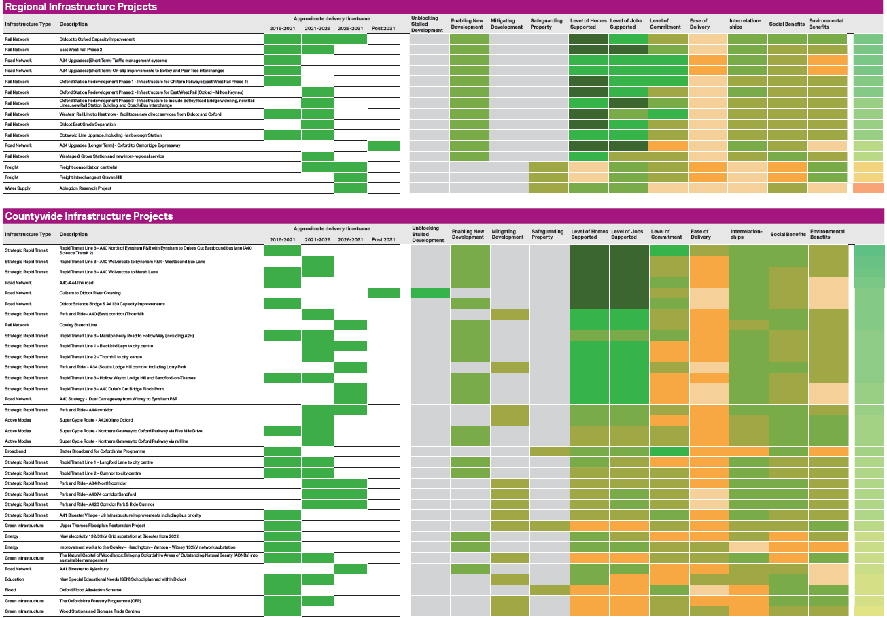

Appendix Three: Growth Corridor Petal diagram

